Chinese words showing on my website while on google search results
Client Name: Alan Tardieu
Client Site: clovespringrange.com
Screenshot of the issue:
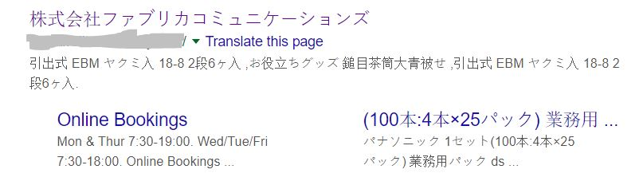

- Overview: We got the email from site owner that they noticed his website was showing Chinese words on Google search results, even though his site was in English. He was worried that this is going to affect his site's ranking, traffic, and reputation. He wanted to find out the cause and the solution for this issue.

- Challenges: Client faced these following challenges in dealing with the issue of Chinese words showing on his website while on Google search results, such as:

• He did not know how the Chinese words got into his site or his Google search results.
• He did not know how to remove the Chinese words from his site or his Google search results.
• He did not know how to prevent the issue from happening again in the future.

- Solutions:
We have followed these steps,
- We scanned the complete website on online virus scanner websites and removed all the infected file found in report, using the hosting Cpanel and FTP.
https://scanner.pcrisk.com/

- Checked the website on Google safe browsing ( It was showing fine here )
https://transparencyreport.google.com/safe-browsing/search?hl=en

- Checked htaccess and wp-config files
- Removed unauthorized admin users
- Remove unused WordPress themes and plugins
- Install the All In One Security and enabled these things
• Remove WP version info
• Change admin username
• Login lockout
• Force user logout options
• Manually approve new registrations
• Enable math CAPTCHA on registration and login page
• Change Database prefix
• Disable PHP file editing from the website dashboard
• Prevent access to default WP files
• Enable firewall settings
• WordPress XMLRPC and pingback vulnerability protection
• Disable index views
• Disable trace and track
• Forbid proxy comment posting
• Enable advanced character string filter
• Enable 6G blacklist/firewall settings
• Block fake Googlebots
• Prevent image hotlinking
• Enable math CAPTCHA on comment forms
• Enable auto block of spam comment IPs
• Enable automated file change detection scan
After performing all the above steps and made the site clean, we prepared a new fresh backup of the site for future security purpose.
After cleaning the site we verified his site ownership on Google Search Console and requested a re-indexing of his site. We also checked his site's performance, coverage, and security issues on Google Search Console.
Once the site is verified, we checked the site in Google search engine and everything was showing normal again. See the screenshot for example:
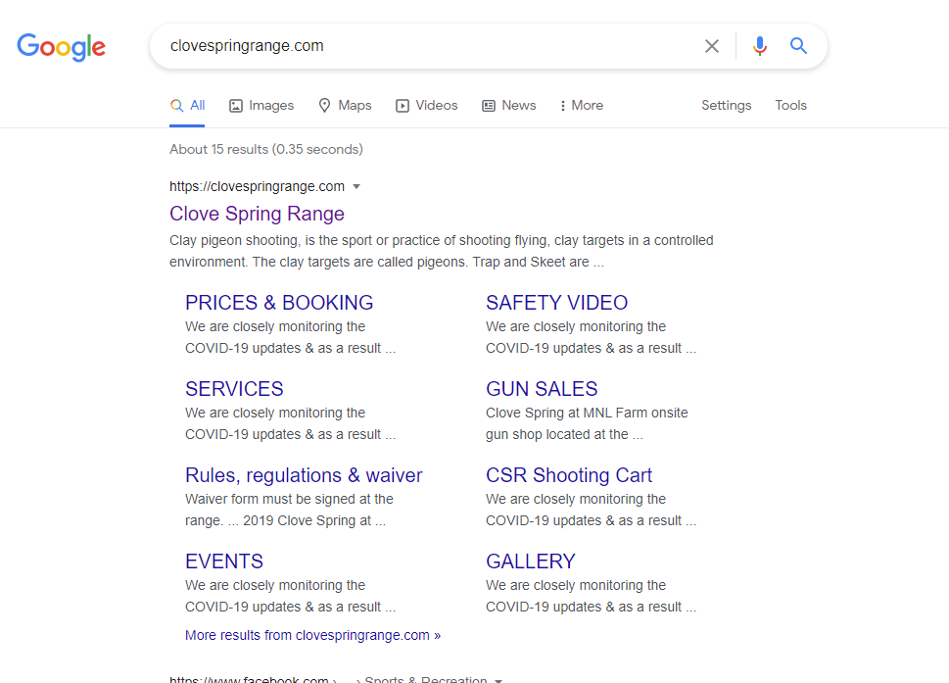
- Conclusion: By applying these solutions, we were able to fix the issue of Chinese words showing on client website while on google search results. We also improved his site's security, performance, and ranking.

